User's input page:

When create a new model, user need to finish settings in 3 steps:

1. Basic info settings

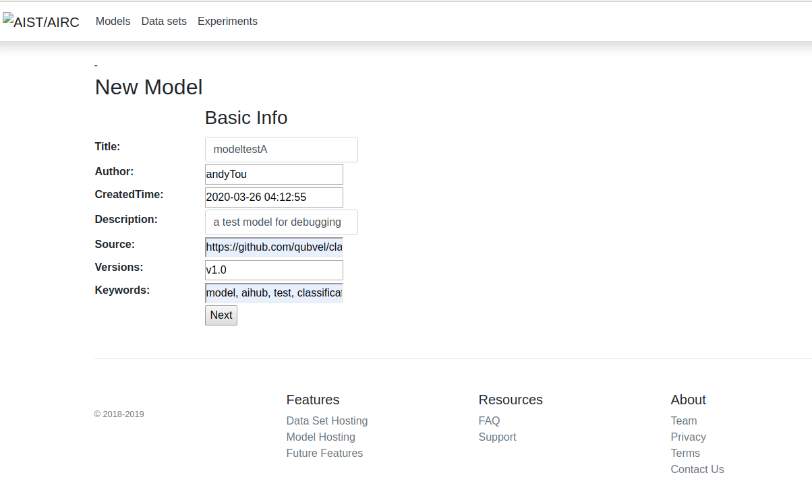

1. Network settings

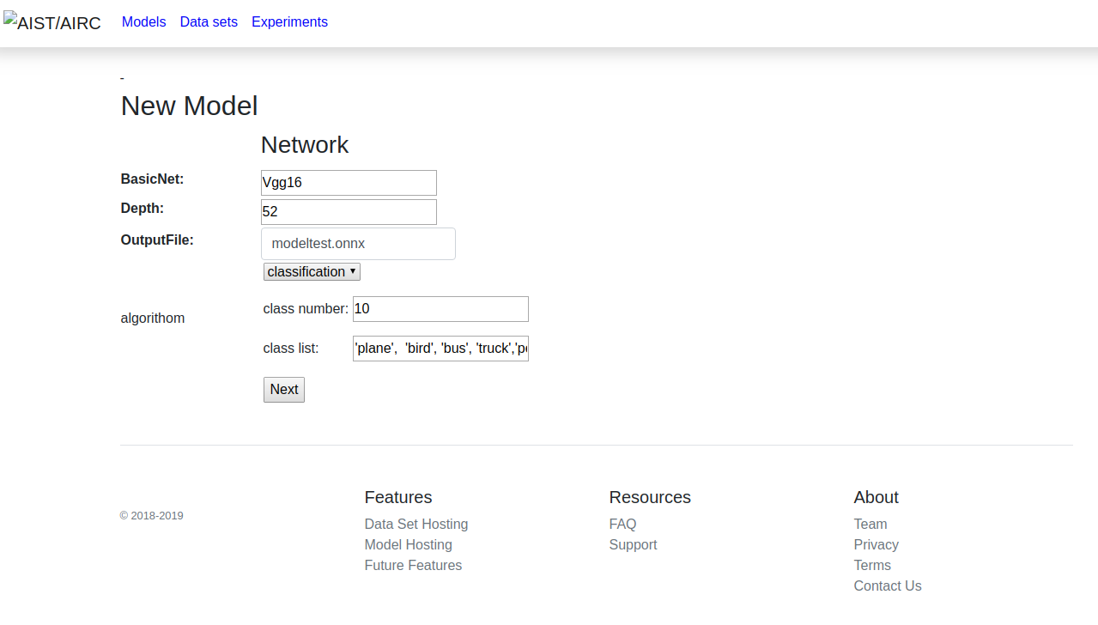

1. Training settings

